1) word count. (single function pass file.read file and count each words count, make the output in the same location in csv format).

import os

def fileread():

#create an file called practise

file=open("practise.csv","w")

file.write('uwckwuckuh')

file.close()

#append the file

file=open("practise.csv","a")

file.write("iksdhncwi\n cat and dog \n mouse and cat\n")

file.close()

# read the file

#count the no of words in the file

file=open("practise.csv","r")

content=file.read()

word=content.split()

num_of_words=len(word)

print("num_of_words",num_of_words)

file.close()

fileread()

2) ip validation( ipv4 and ipv6 have different function and validate).

Ipv4 validation

def validate_ipv4(ipv4):

parts = ipv4.split('.')

if len(parts) != 4:

return False

for part in parts:

if not part.isdigit():

return False

num = int(part)

if num < 0 or num > 255:

return False

return True

ipv4 = input("Enter the IPv4 address: ")

print(validate_ipv4(ipv4))

ipv6 validation:

def validate_ipv6(ipv6):

parts = ipv6.split(':')

if len(parts) != 8:

return False

for part in parts:

if not (1 <= len(part) >=4):

return False

try:

int(part,16)

except ValueError:

return False

return True

ipv6=input("Enter the ipv6 :")

print(validate_ipv6(ipv6))

3) String validation= c6*Dwu35ae2024 ( String should have last 4 digit as number,

3rd character should be *, 4th character should be uppercase, from last 5th character should be alphabet, total char should be <=14). if failure each validation should be printed which dont obey. if success return success.

def validate_string(strr):

if len(strr) > 14:

return "Failure: The length should be less than or equal to 14"

if strr[2] != '*':

return "Failure :The 3rd character should be *"

if not strr[3].isupper():

return "Failure: 4th character should be uppercase"

if not strr[-5].isalpha():

return "Failure: last 5th character should be alphabet"

if not strr[-4:].isdigit():

return "Failure: The last four digit should be numbers"

else:

return "Success"

strr=input("Enter the string: ")

print(validate_string(strr))

4)find and replace. take file path as input, what word , which word is used to replace.

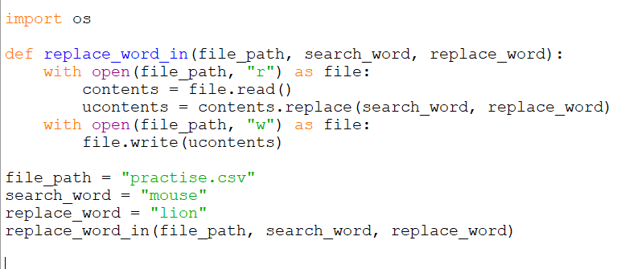

import os

def replace_word_in(file_path, search_word, replace_word):

with open(file_path, "r") as file:

contents = file.read()

ucontents = contents.replace(search_word, replace_word)

with open(file_path, "w") as file:

file.write(ucontents)

file_path = "practise.csv"

search_word = "mouse"

replace_word = "lion"

replace_word_in(file_path, search_word, replace_word)

5)Find the next highest number by swapping the digit of the input given. ex 364179 -> 364197 swap two numbers to get next greater number.

def validate_num(num):

lst=list(str(num))

for i in range(len(lst)-1, 0, -1):

if lst[i]>lst[i-1]:

lst[i-1],lst[i]=lst[i],lst[i-1]

return int("".join(lst))

return -1

num = int(input("Enter the number :"))

result=validate_num(num)

if result == -1 :

print("In the given number we cant find the highest number")

else:

print("The next highest number is",result)

core python poc use case.